**IT2120 - Probability and Statistics**

**IT24103994**

**NETHMA L.W.K.**

**Lab Sheet 08**

Exercise

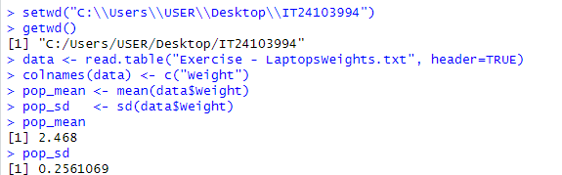

02)

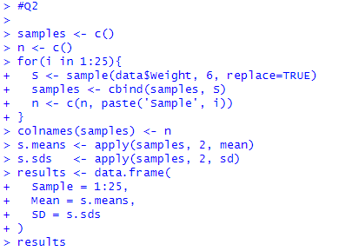

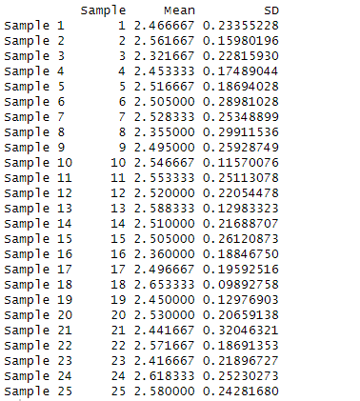

03)

